**T.C.**



**ABDULLAH GÜL UNIVERSITY STUDENT AFFAIRS DEPARTMENT HEADSHIP**

**UNDERGRADUATE STUDENT DISCHARGE FORM**

My clear identity and educational information are written below, and I have been dismissed from your university for the reason indicated below. I would like my documents regarding the matter to be prepared and given to me. I hereby declare that I have no relations with other units of your university other than those specified by the signatures of the authorities below.

I kindly request your information and the necessary action.

......./…..../20…...

Full Name :

# Signature : ÖĞRENCİNİN

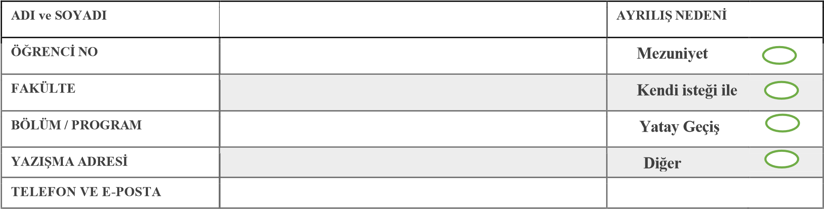

**TO THE RELEVANT UNITS:** I kindly request that the student with the above information who wishes to terminate his/her relationship with our university sign the form explaining whether he/she has a relationship with your unit or not.

|  |  |  |
| --- | --- | --- |
| UNITS | UNIT | OFFICIAL |
|  | **Full Name/Signature** | **Date/Explanation** |
| **Head of Department** |  |  |
| **Library Department** |  |  |
| **SKS Department** |  |  |
| **Dean of Students Office** |  |  |
| **Dormitory Directorate** |  |  |
| **AGÜV (Except for Graduate Students and Those Who Do Not Purchase a Computer)** |  |  |
| **Department of Information Technology** |  |  |
| **Department of Student Affairs** |  | **ID taken** |
|  | **There is no fee debt** |